 |  | 
Faculty of Technology and Engineering
Chandubhai S. Patel Institute of Technology (CSPIT)
Department of Computer Science & Engineering
Date: 29/09/2026
Laboratory Manual
Academic Year | : | 2026-27 | Semester | : | 3rd
Course code | : | ITUE203 | Course name | : | WEB DEVELOPMENT FRAMEWORKS

Practical – 4
JavaScript DOM Manipulation, Event Handling, and UI Interactivity
Problem Statement:- Add dynamic UI components such as collapsible FAQ, modal popup, image/content slider, notification banner, hamburger menu, and light/dark
theme switcher using JavaScript.

Objective:- To design and develop a dynamic and interactive web page using JavaScript by implementing UI components such as a collapsible FAQ, modal popup, image/content slider, notification banner, hamburger menu, and light/dark theme switcher.

Github Repository Link:- https://github.com/Nishtha-cse/StudentHubPortal-D26CS129

Light/Dark theme switcher :
Theme.js file:
// ================= THEME SWITCHER =================
(function () {
"use strict";
var STORAGE_KEY = "studenthub-theme";
var root = document.documentElement;

function currentTheme() {
return root.getAttribute("data-theme") === "dark" ? "dark" : "light";
}

function updateLabel(toggle) {
var isDark = currentTheme() === "dark";
toggle.setAttribute("aria-pressed", String(isDark));
toggle.textContent = isDark ? "\u2600\uFE0F Light mode" : "\uD83C\uDF19 Dark mode";
}

document.addEventListener("DOMContentLoaded", function () {
// Restore saved choice (the tiny script in <head> already avoids a flash)
var stored = localStorage.getItem(STORAGE_KEY);
if (stored === "dark" || stored === "light") {
root.setAttribute("data-theme", stored);
}

var toggle = document.getElementById("theme-toggle");
if (!toggle) return;
updateLabel(toggle);

toggle.addEventListener("click", function () {
var next = currentTheme() === "dark" ? "light" : "dark";
root.setAttribute("data-theme", next);
localStorage.setItem(STORAGE_KEY, next);
updateLabel(toggle);
});
});
})();

Home.html in light mode:
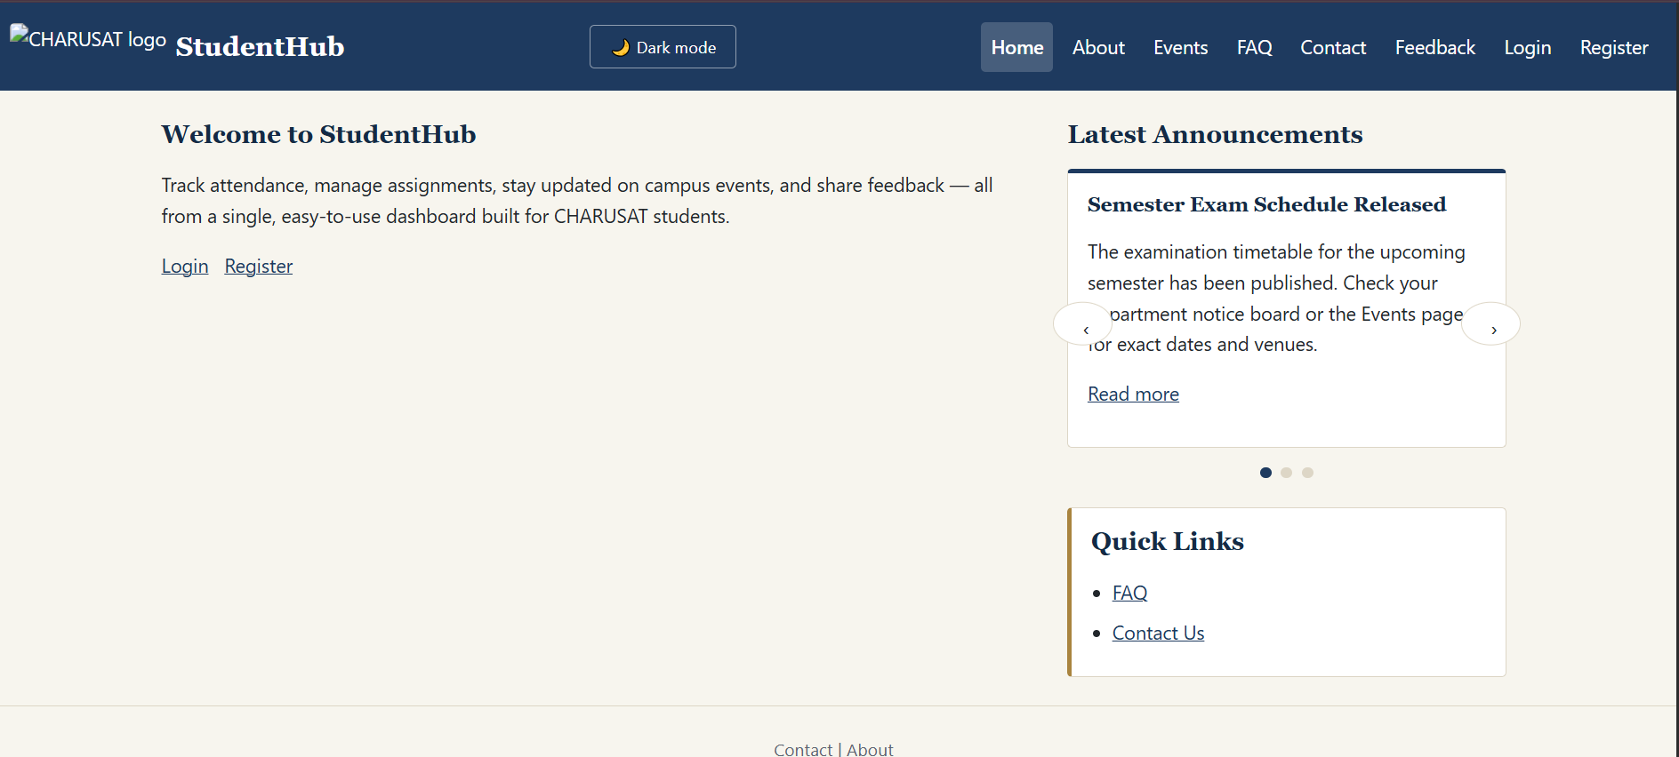
Home.html page in dark mode:
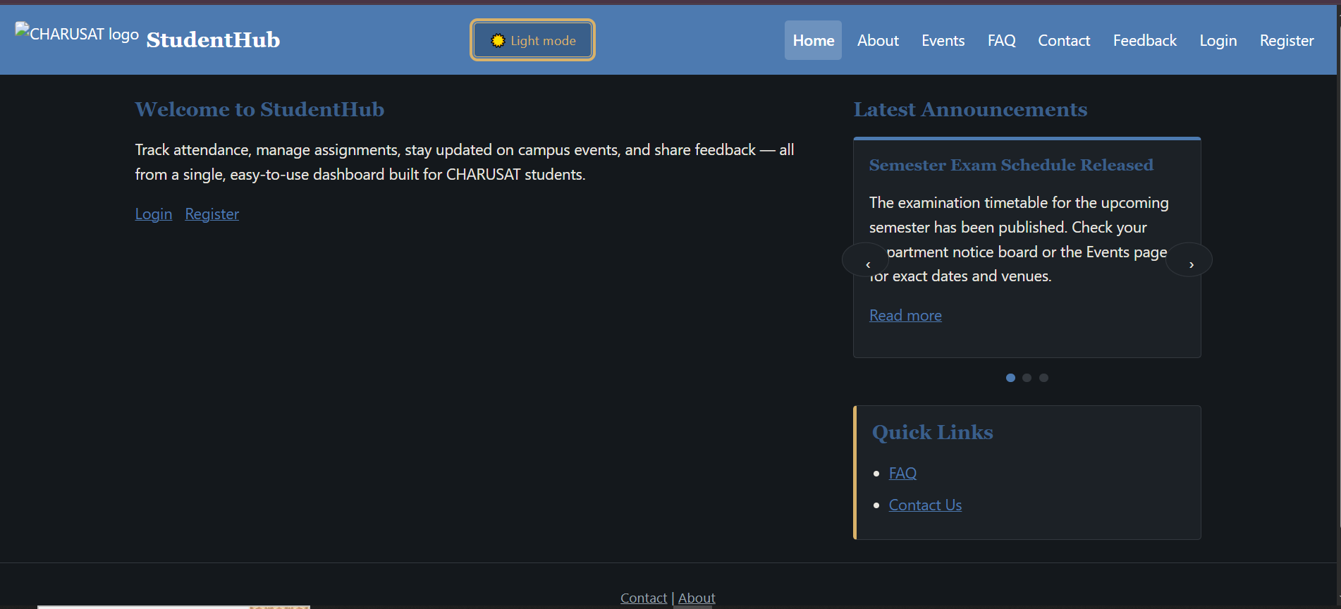

Collapsible FAQ :
Faqs.html :
<!DOCTYPE html>
<html lang="en">
<head>
<meta charset="UTF-8">
<meta name="viewport" content="width=device-width, initial-scale=1.0">
<link rel="stylesheet" href="../css/style.css">
<link rel="icon" href="../images/charusat.png" type="image/png">
<title>FAQs - StudentHub</title>
<meta name="description" content="Frequently asked questions about using StudentHub.">
<script>
(function () {
var saved = localStorage.getItem("studenthub-theme");
if (saved === "dark" || saved === "light") {
document.documentElement.setAttribute("data-theme", saved);
}
})();
</script>
</head>
<body>
<header>
<div class="brand">
<img src="../images/charusat.png" alt="CHARUSAT logo">
<h1>Frequently Asked Questions</h1>
</div>
<div class="header-actions">
<button type="button" id="theme-toggle" class="theme-toggle" aria-pressed="false">Dark mode</button>
<button type="button" class="nav-toggle" aria-controls="primary-nav" aria-expanded="false">
<span class="hamburger-icon" aria-hidden="true"></span>
<span>Menu</span>
</button>
</div>
<nav aria-label="Main navigation" id="primary-nav">
<ul>
<li><a href="home.html">Home</a></li>
<li><a href="about.html">About</a></li>
<li><a href="event.html">Events</a></li>
<li><a href="faqs.html" aria-current="page">FAQ</a></li>
<li><a href="contact.html">Contact</a></li>
<li><a href="feedback.html">Feedback</a></li>
<li><a href="login.html">Login</a></li>
<li><a href="register.html">Register</a></li>
</ul>
</nav>
</header>

<main id="main-content">
<section aria-label="Frequently asked questions">
<div class="accordion-item">
<h2>
<button type="button" class="accordion-trigger" id="faq1-trigger" aria-expanded="false" aria-controls="faq1-panel">
How to reset the password?
</button>
</h2>
<div class="accordion-panel" id="faq1-panel" role="region" aria-labelledby="faq1-trigger" hidden>
<p>You can reset your password by clicking the "Forgot Password" link on the login page and following the instructions.</p>
</div>
</div>

<div class="accordion-item">
<h2>
<button type="button" class="accordion-trigger" id="faq2-trigger" aria-expanded="false" aria-controls="faq2-panel">
How to update profile information?
</button>
</h2>
<div class="accordion-panel" id="faq2-panel" role="region" aria-labelledby="faq2-trigger" hidden>
<p>You can update your profile information by navigating to the "Profile" section and clicking the "Edit Profile" button.</p>
</div>
</div>

<div class="accordion-item">
<h2>
<button type="button" class="accordion-trigger" id="faq3-trigger" aria-expanded="false" aria-controls="faq3-panel">
How to change the email address?
</button>
</h2>
<div class="accordion-panel" id="faq3-panel" role="region" aria-labelledby="faq3-trigger" hidden>
<p>You can change your email address by going to the "Profile" section and clicking the "Edit Profile" button.</p>
</div>
</div>
</section>
</main>

<footer>
<nav aria-label="Footer navigation">
<a href="contact.html">Contact</a> |
<a href="about.html">About</a>
</nav>
<p>&copy; 2026 StudentHub</p>
</footer>

<script src="../js/theme.js" defer></script>
<script src="../js/menu.js" defer></script>
<script src="../js/accordion.js" defer></script>
</body>
</html>

accordion.js :
<!-- ================= FAQ ACCORDION ================= -->

(function () {
"use strict";

document.addEventListener("DOMContentLoaded", function () {
document.querySelectorAll(".accordion-trigger").forEach(function (trigger) {
trigger.addEventListener("click", function () {
var panelId = trigger.getAttribute("aria-controls");
var panel = panelId ? document.getElementById(panelId) : null;
var isExpanded = trigger.getAttribute("aria-expanded") === "true";

trigger.setAttribute("aria-expanded", String(!isExpanded));
if (panel) panel.hidden = isExpanded;
});
});
});
})();

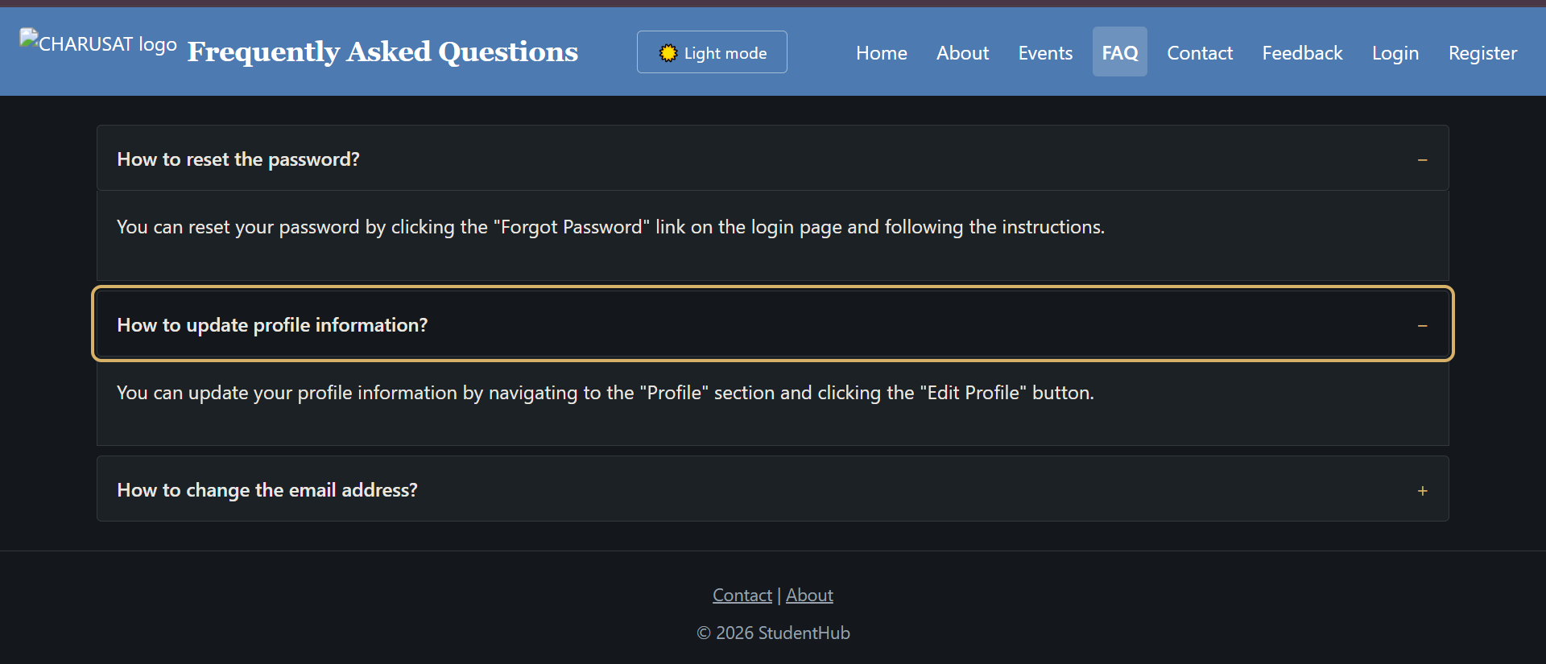

Modal popup
profile.html :
<!-- ================= MODAL POPUP ================= -->

<div class="modal-overlay" id="edit-profile-modal" role="dialog" aria-modal="true" aria-labelledby="edit-profile-title" hidden>
<div class="modal">
<button type="button" class="modal-close" aria-label="Close dialog">&times;</button>
<h2 id="edit-profile-title">Edit Profile</h2>
<form action="#" method="post">
<label for="edit-phone">Phone Number</label><br>
<input type="tel" id="edit-phone" name="phone" value="+91 98765 43210"><br><br>

<label for="edit-semester">Semester</label><br>
<input type="text" id="edit-semester" name="semester" value="5th"><br><br>

<button type="submit">Save Changes</button>
</form>
</div>
</div>

style.css :
/* ================= MODAL ================= */

.modal-overlay {
position: fixed;
inset: 0;
background: rgba(20, 24, 28, 0.6);
display: flex;
align-items: center;
justify-content: center;
padding: var(--space-2);
z-index: 200;
}
.modal-overlay[hidden] { display: none; }
.modal {
background: var(--color-surface);
border-radius: var(--radius);
padding: var(--space-3);
max-width: 28rem;
width: 100%;
position: relative;
}
.modal-close {
position: absolute;
top: var(--space-1);
right: var(--space-1);
background: transparent;
border: none;
padding: 0;
font-size: 1.3rem;
cursor: pointer;
color: var(--color-muted);
}
modal.js :
// ================= MODAL POPUP =================

(function () {
"use strict";

document.addEventListener("DOMContentLoaded", function () {
var lastTrigger = null;

function openModal(modal, trigger) {
lastTrigger = trigger;
modal.hidden = false;
document.body.classList.add("modal-open");
var focusTarget = modal.querySelector("input, textarea, select, button, [href]");
if (focusTarget) focusTarget.focus();
}

function closeModal(modal) {
modal.hidden = true;
document.body.classList.remove("modal-open");
if (lastTrigger) lastTrigger.focus();
}

// Any button with data-modal-target="<modal id>" opens that modal
document.querySelectorAll("[data-modal-target]").forEach(function (trigger) {
var modal = document.getElementById(trigger.dataset.modalTarget);
if (!modal) return;
trigger.addEventListener("click", function () { openModal(modal, trigger); });
});

document.querySelectorAll(".modal-overlay").forEach(function (modal) {
var closeBtn = modal.querySelector(".modal-close");
if (closeBtn) closeBtn.addEventListener("click", function () { closeModal(modal); });

// Click on the dark background closes it
modal.addEventListener("click", function (event) {
if (event.target === modal) closeModal(modal);
});

modal.addEventListener("keydown", function (event) {
if (event.key === "Escape") { closeModal(modal); return; }

// Keep Tab focus inside the open dialog
if (event.key === "Tab") {
var items = modal.querySelectorAll("button, [href], input, textarea, select");
if (!items.length) return;
var first = items[0];
var last = items[items.length - 1];
if (event.shiftKey && document.activeElement === first) {
event.preventDefault(); last.focus();
} else if (!event.shiftKey && document.activeElement === last) {
event.preventDefault(); first.focus();
}
}
});
});
});
})();

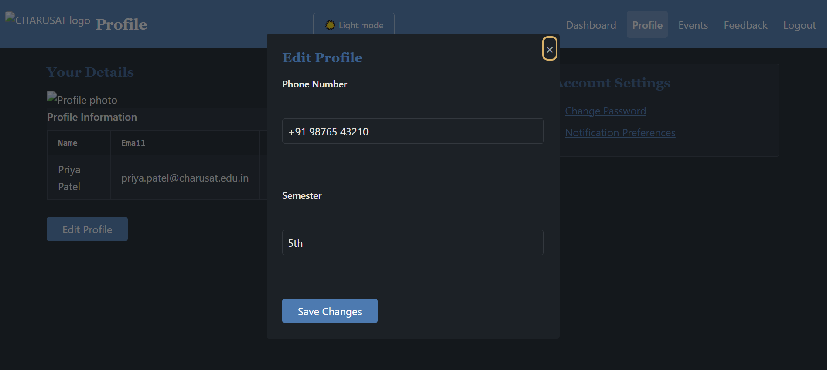

Image/content slider :
home.html:
<!-- ================= CONTENT SLIDER ================= -->

<div class="slider" aria-roledescription="carousel" aria-label="Latest announcements">
<div class="slider-track">
<article class="slide">
<h3>Semester Exam Schedule Released</h3>
<p>The examination timetable for the upcoming semester has been published. Check your department notice board or the Events page for exact dates and venues.</p>
<p><a href="event.html">Read more</a></p>

</article>

<article class="slide" hidden>
<h3>Annual Tech Fest Registrations Open</h3>
<p>Sign up now for workshops, coding contests, and guest talks at this year's tech fest. Limited seats available for select sessions.</p>
<p><a href="event.html">Read more</a></p>

</article>

<article class="slide" hidden>
<h3>Library Timings Extended</h3>
<p>The central library will now stay open until 9 PM on weekdays during the exam period to support student preparation.</p>
<p><a href="event.html">Read more</a></p>
</article>
</div>
<button type="button" class="slider-prev" aria-label="Previous announcement">&#8249;</button>
<button type="button" class="slider-next" aria-label="Next announcement">&#8250;</button>
<div class="slider-dots" role="tablist" aria-label="Choose announcement"></div>

</div>
style.css:
/* ================= CONTENT SLIDER ================= */

.slider { position: relative; }
.slider-track { position: relative; min-height: 8rem; }
.slide[hidden] { display: none; }
.slider-prev, .slider-next {
position: absolute;
top: 50%;
transform: translateY(-50%);
background: var(--color-surface);
border: 1px solid var(--color-border);
border-radius: 50%;
width: 2.25rem;
height: 2.25rem;
cursor: pointer;
font-size: 1.1rem;
}
.slider-prev { left: -0.75rem; }
.slider-next { right: -0.75rem; }
.slider-dots {
display: flex;
justify-content: center;
gap: var(--space-1);
margin-top: var(--space-2);
}
.slider-dots button {
width: 0.6rem;
height: 0.6rem;
border-radius: 50%;
border: none;
background: var(--color-border);
padding: 0;
cursor: pointer;
}
.slider-dots button[aria-selected="true"] { background: var(--color-primary); }

Slider.js:
// ================= CONTENT SLIDER =================

/* Feature 6: Content slider (prev / next buttons, dots, keyboard arrows) */
(function () {
"use strict";

document.addEventListener("DOMContentLoaded", function () {
document.querySelectorAll(".slider").forEach(function (slider) {
var slides = Array.from(slider.querySelectorAll(".slide"));
if (slides.length === 0) return;

var prevBtn = slider.querySelector(".slider-prev");
var nextBtn = slider.querySelector(".slider-next");
var dotsWrap = slider.querySelector(".slider-dots");
var index = 0;

// Build one dot per slide
if (dotsWrap) {
dotsWrap.innerHTML = "";
slides.forEach(function (_, i) {
var dot = document.createElement("button");
dot.type = "button";
dot.setAttribute("role", "tab");
dot.setAttribute("aria-label", "Go to slide " + (i + 1));
dot.addEventListener("click", function () { show(i); });
dotsWrap.appendChild(dot);
});
}
var dots = dotsWrap ? Array.from(dotsWrap.children) : [];

function show(newIndex) {
index = (newIndex + slides.length) % slides.length; // wraps around
slides.forEach(function (slide, i) { slide.hidden = i !== index; });
dots.forEach(function (dot, i) {
dot.setAttribute("aria-selected", String(i === index));
});
}

if (prevBtn) prevBtn.addEventListener("click", function () { show(index - 1); });
if (nextBtn) nextBtn.addEventListener("click", function () { show(index + 1); });

slider.addEventListener("keydown", function (event) {
if (event.key === "ArrowLeft") show(index - 1);
if (event.key === "ArrowRight") show(index + 1);
});

show(0);
});
});
})();

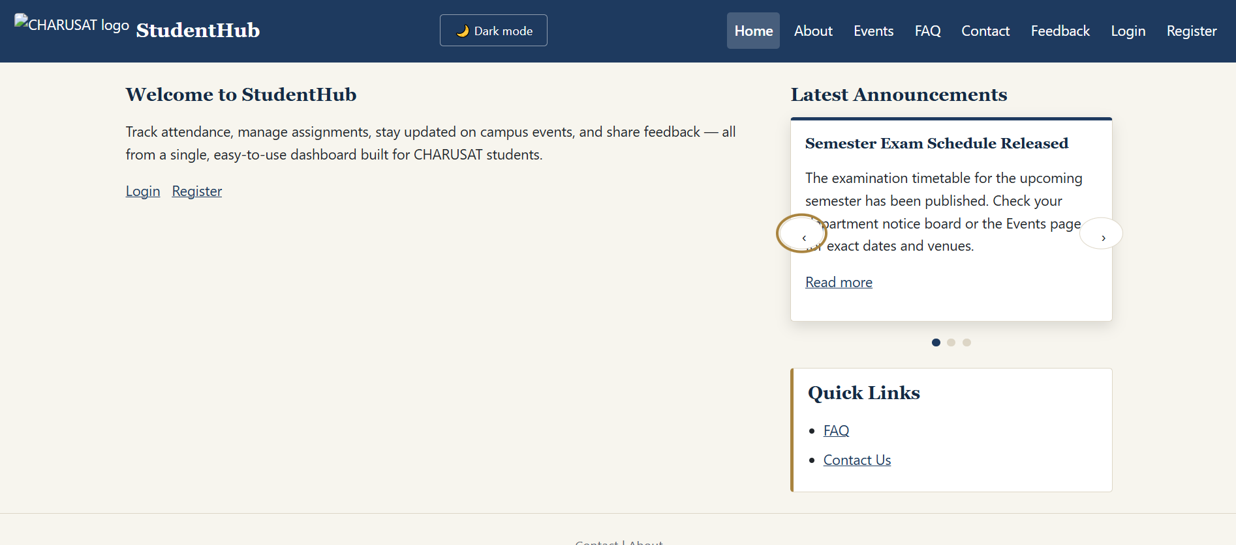

Notification banner :
home.html:
<!-- ================= NOTIFICATION BANNER ================= -->

<div class="notice-banner" id="notice-banner" data-notice-id="techfest-2026" role="status">
<p>New: Annual Tech Fest registrations are now open &mdash; see Latest Announcements below.</p>
<button type="button" class="notice-close" aria-label="Dismiss notification">&times;</button>

</div>
Style.css:
/* ================= NOTIFICATION BANNER ================= */

.notice-banner {
background: var(--color-accent);
color: var(--color-primary-dark);
padding: var(--space-1) var(--space-2);
display: flex;
align-items: center;
justify-content: center;
gap: var(--space-2);
font-size: 0.9rem;
text-align: center;
}
.notice-banner[hidden] { display: none; }
.notice-banner p { margin: 0; }
.notice-close {
background: transparent;
border: none;
padding: 0;
font-size: 1.2rem;
line-height: 1;
cursor: pointer;
color: inherit;
}
banner.js:
// ================= NOTIFICATION BANNER =================

/* Feature 3: Notification banner (dismissal remembered with localStorage) */
(function () {
"use strict";

document.addEventListener("DOMContentLoaded", function () {
var banner = document.getElementById("notice-banner");
if (!banner) return;

var noticeId = banner.dataset.noticeId || "default";
var storageKey = "studenthub-notice-" + noticeId;

if (localStorage.getItem(storageKey) === "dismissed") {
banner.hidden = true;
return;
}

var closeBtn = banner.querySelector(".notice-close");
if (!closeBtn) return;

closeBtn.addEventListener("click", function () {
banner.hidden = true;
localStorage.setItem(storageKey, "dismissed");
});
});
})();

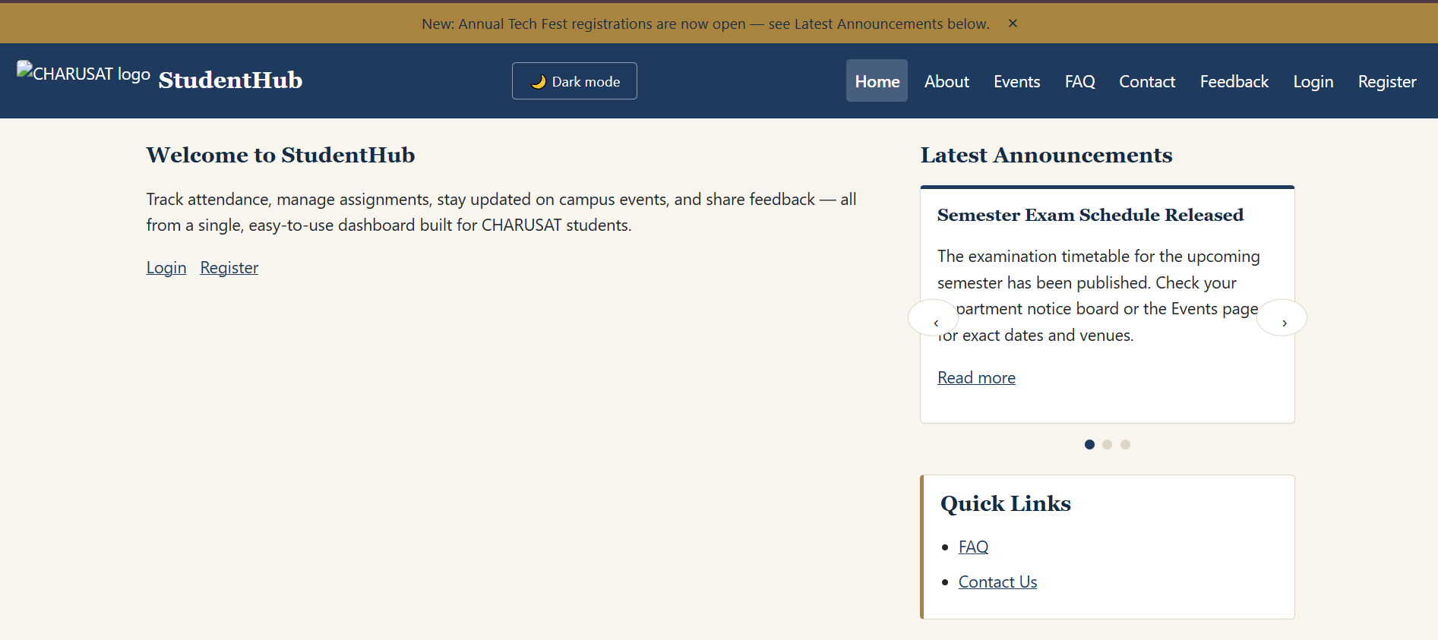

Hamburger menu
Login.html:
<div class="header-actions">
<button type="button" id="theme-toggle" class="theme-toggle" aria-pressed="false">Dark mode</button>
<button type="button" class="nav-toggle" aria-controls="primary-nav" aria-expanded="false">
<span class="hamburger-icon" aria-hidden="true"></span>
<span>Menu</span>
</button>
</div>

